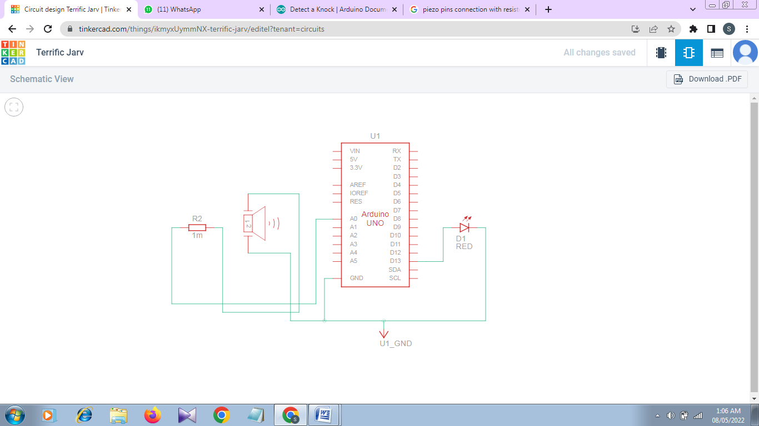**Schematic View:**

**Circuit View:**

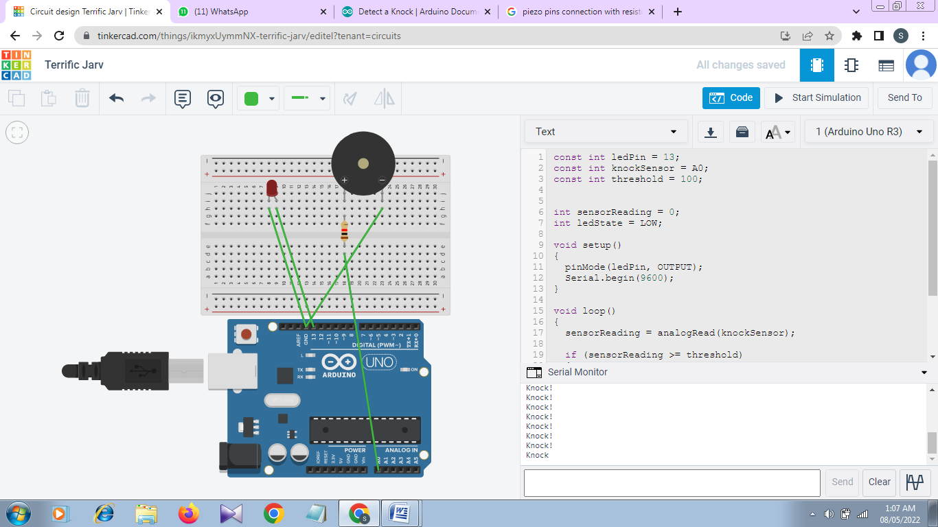

**Code:**

const int ledPin = 13;

const int knockSensor = A0;

const int threshold = 100;

int sensorReading = 0;

int ledState = LOW;

void setup()

{

pinMode(ledPin, OUTPUT);

Serial.begin(9600);

}

void loop()

{

sensorReading = analogRead(knockSensor);

if (sensorReading >= threshold)

{

ledState = !ledState;

digitalWrite(ledPin, ledState);

Serial.println("Knock!");

}

delay(100);

}